Key Management Service and Secret Manager
how to access S3 service by using KSM encryption
objective: To secure sensitive AWS resources (like S3, EBS, RDS, Lambda, etc.) by encrypting data at rest using AWS KMS (Key Management Service) so that only authorized users and services can access the data.
prerequisites:
AWS
IAM USER
KMS
Resource permissions
S3
step by step process:
first we need to create an S3 bucket---bucket name
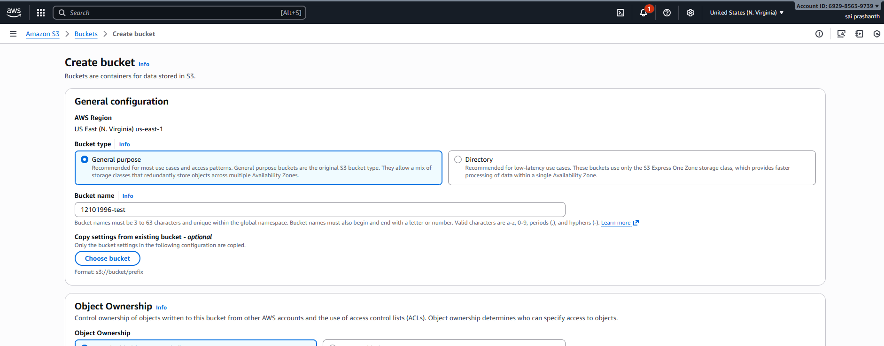
in default encryption you can see automatically one encryption type which is already created by S3 itself—then click on create bucket
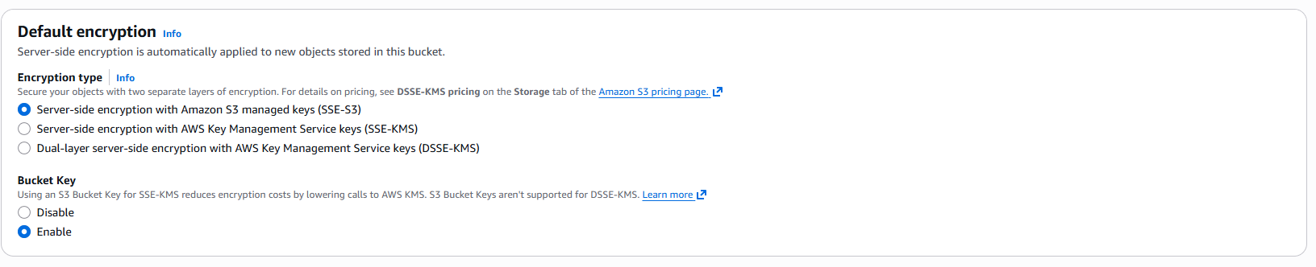
uploaded one object in it
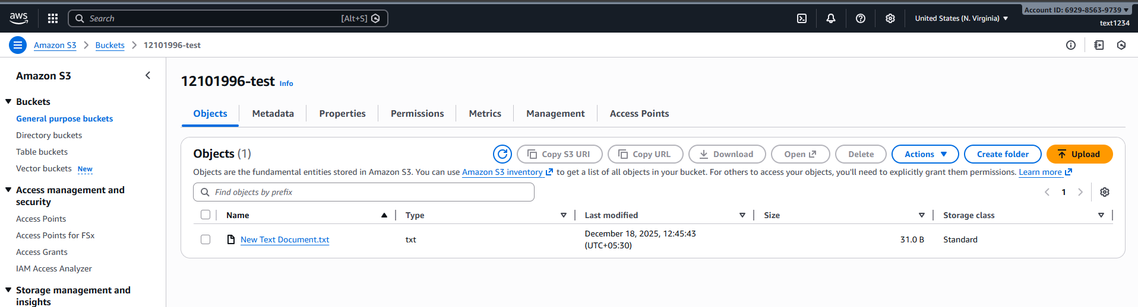

once bucket has been created you can see in properties the default encryption—server-side encryption with Amazon S3 managed keys as it is default created

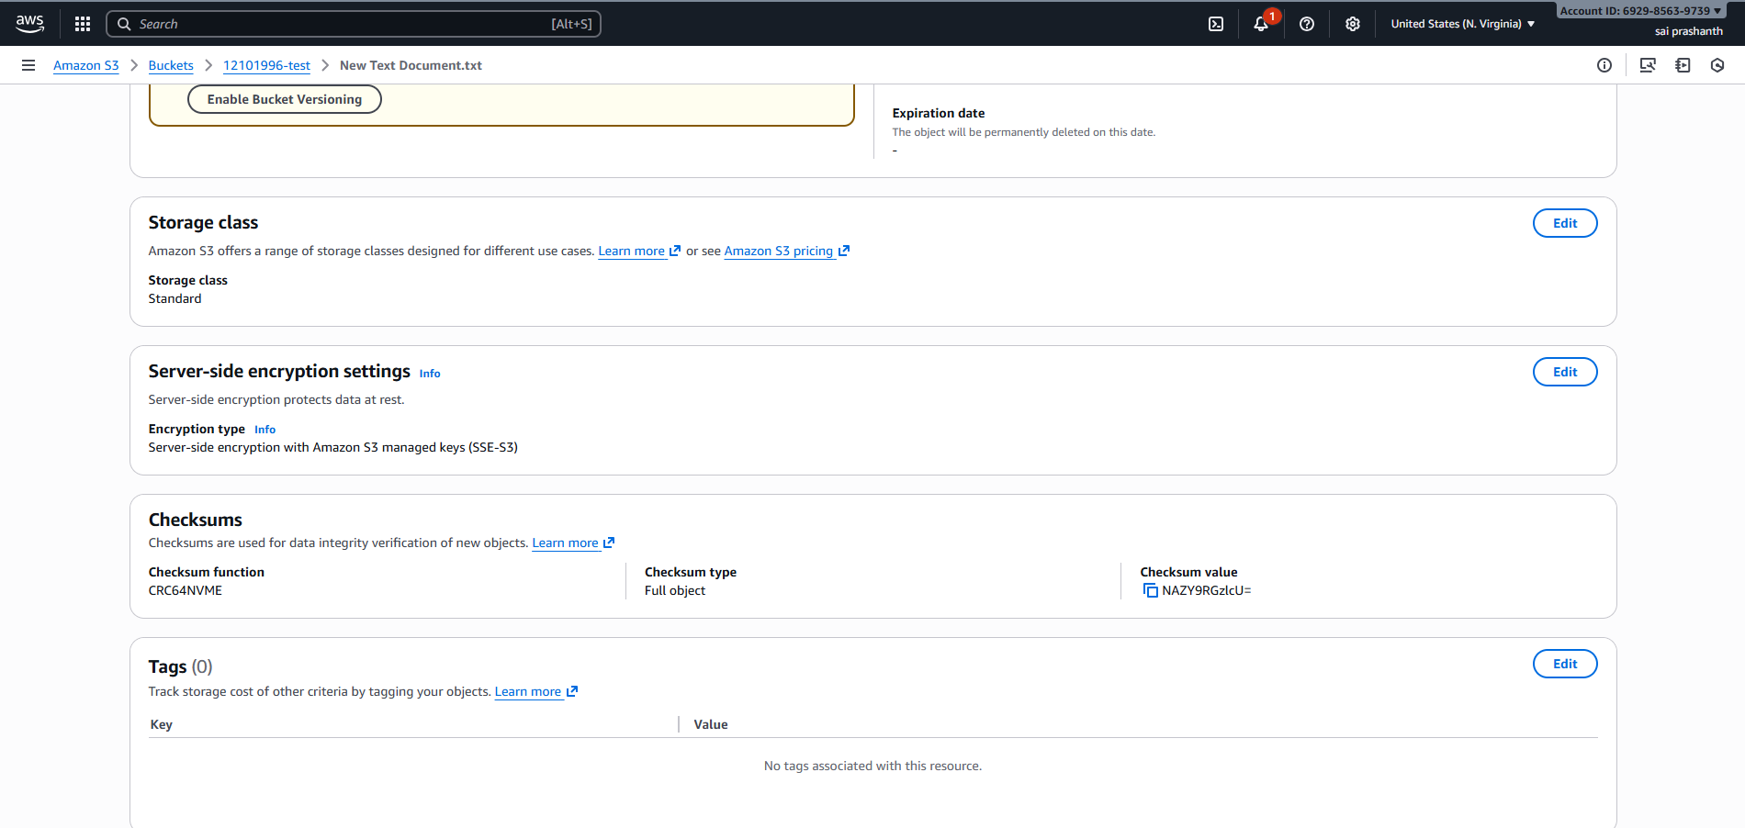

now to view for only particular user---you can create one IAM user and password and set permissions as s3 full access
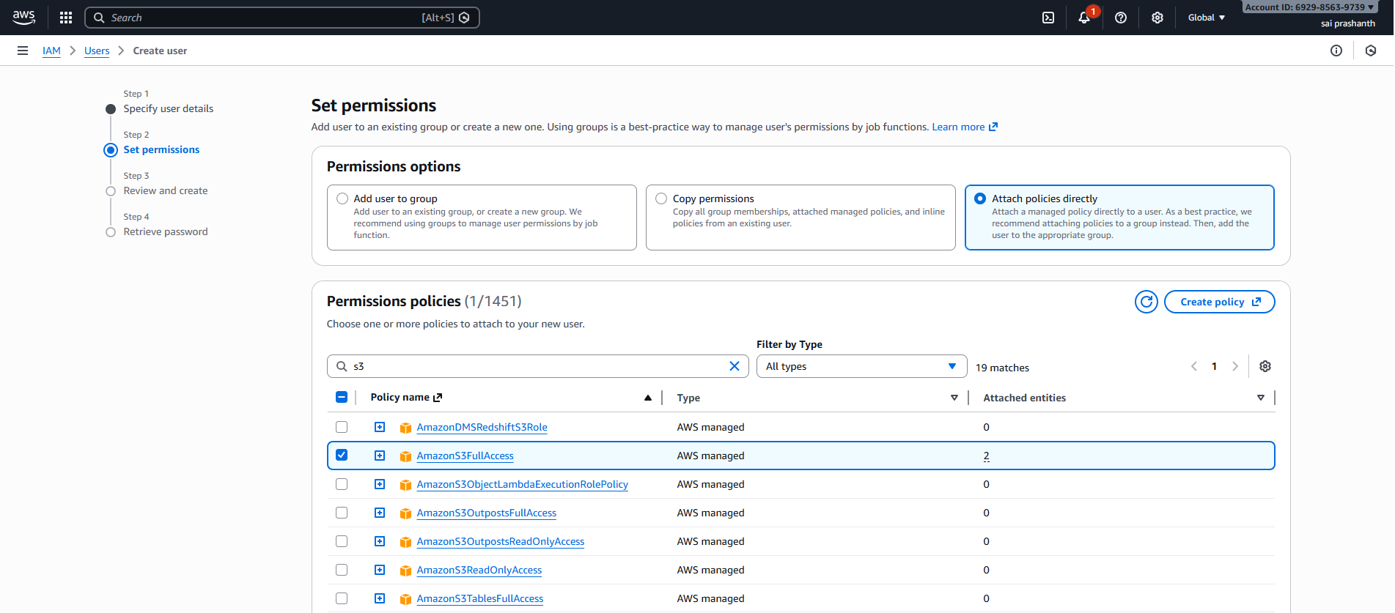
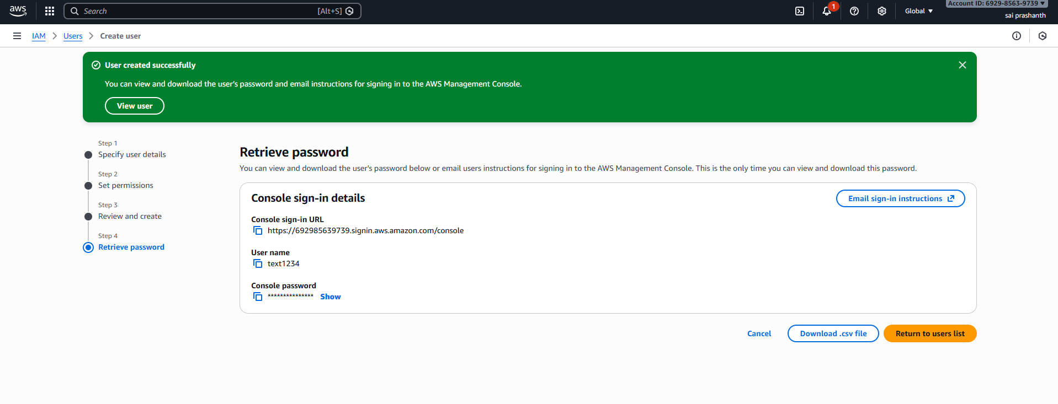now go to Key management service ---click on custom managed keys—click on create key

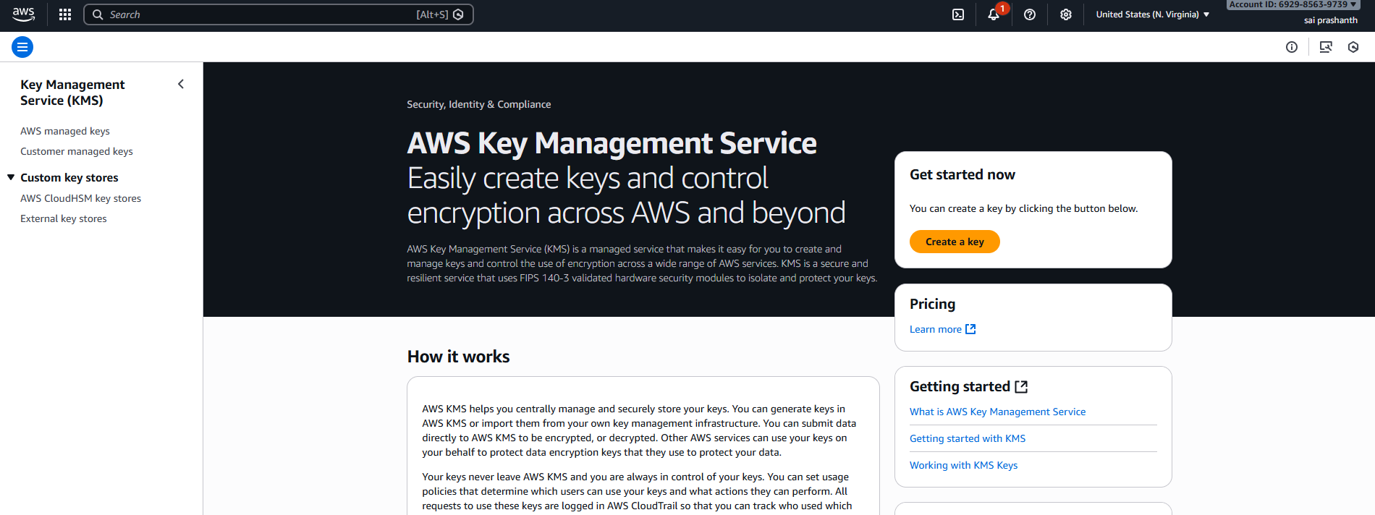
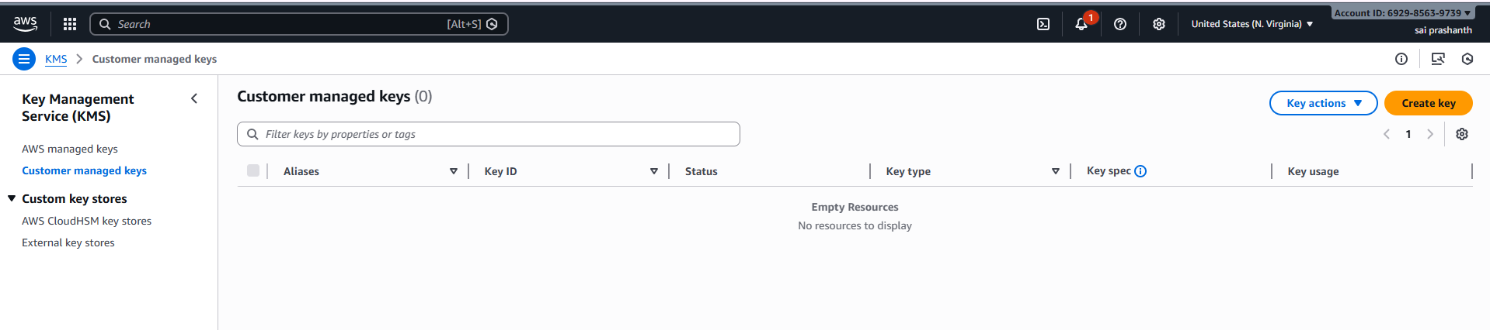
once you clicked on that----select key type symmetric—
key usage—encrypt and decrypt—click on next
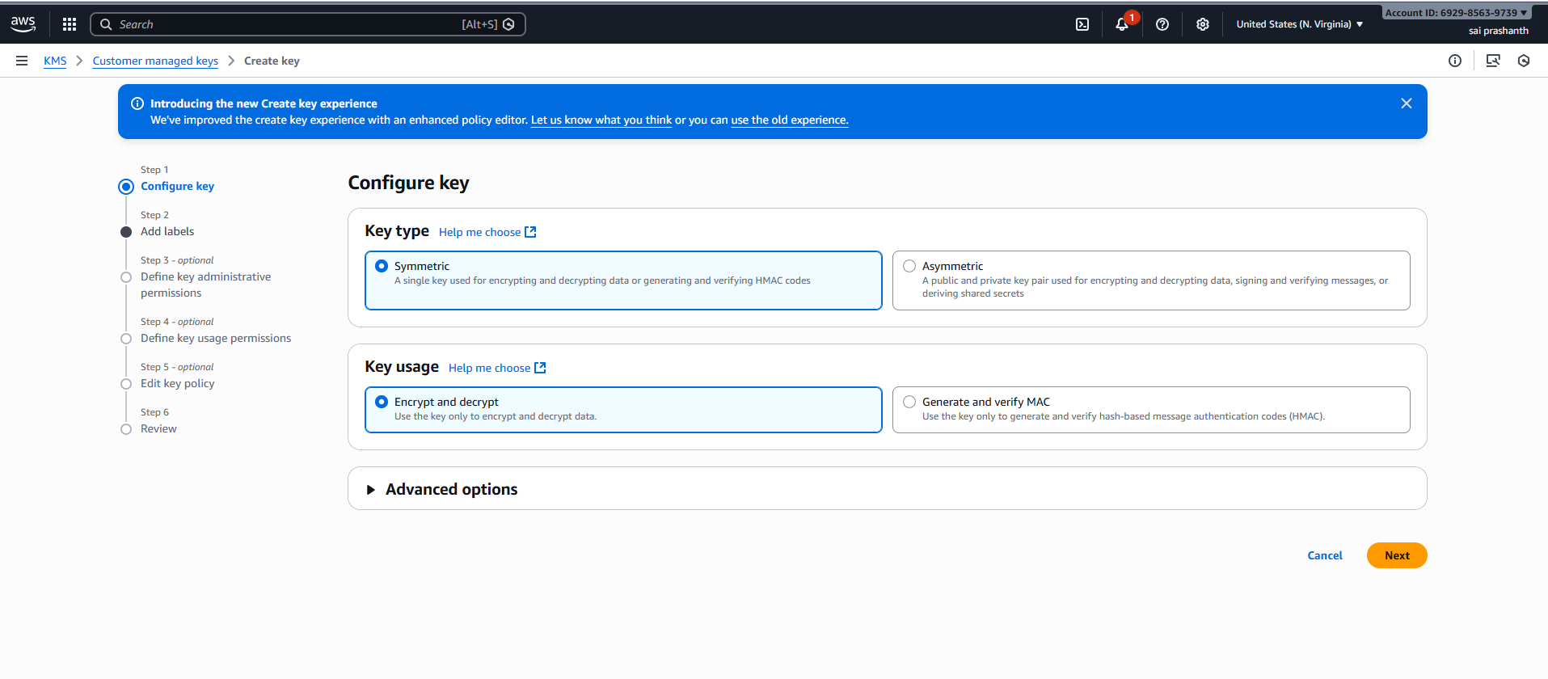
create one name for your key---kmsnewkey-123 I have created—next
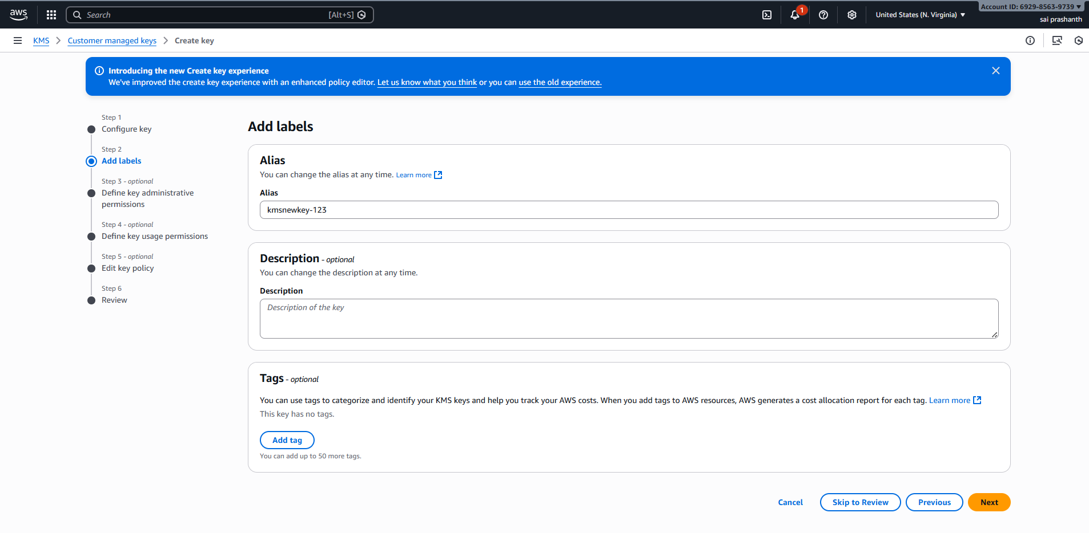

now giving permissions to particular user---here I have created one user already---text1234
so he can delete the key as well
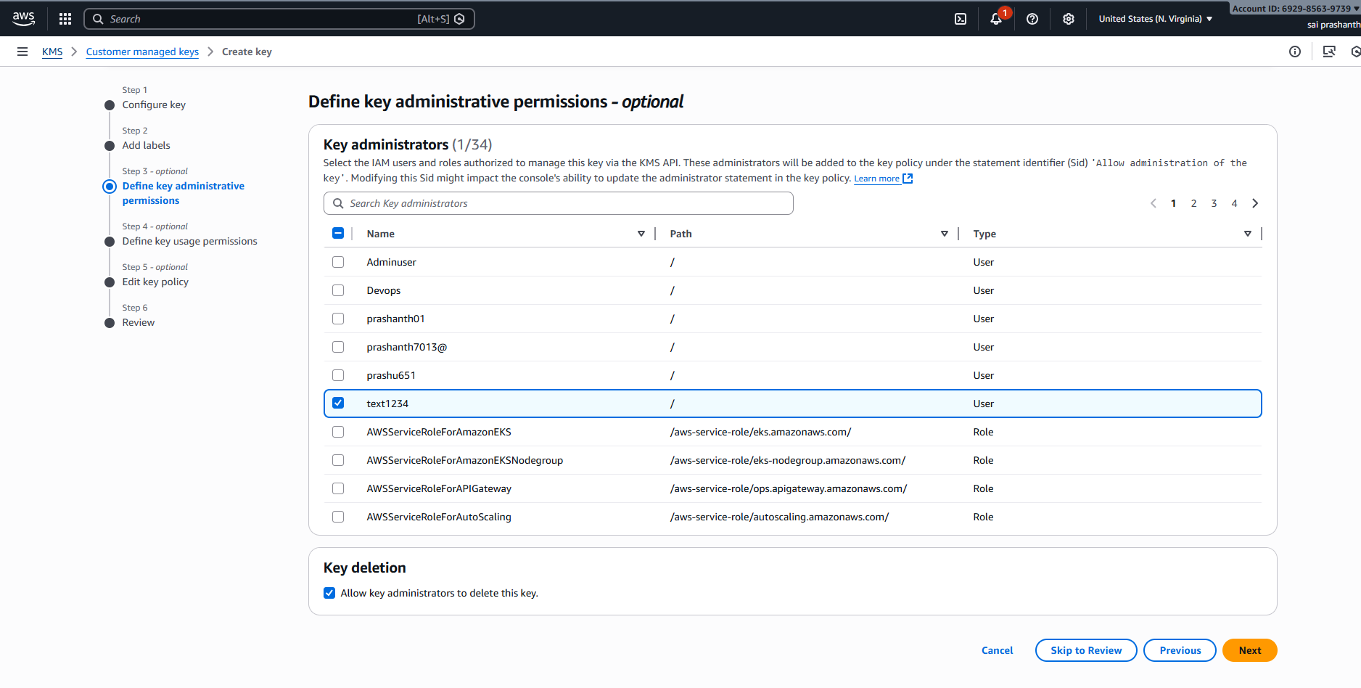
giving key usage permissions—same as same user text1234—click on next
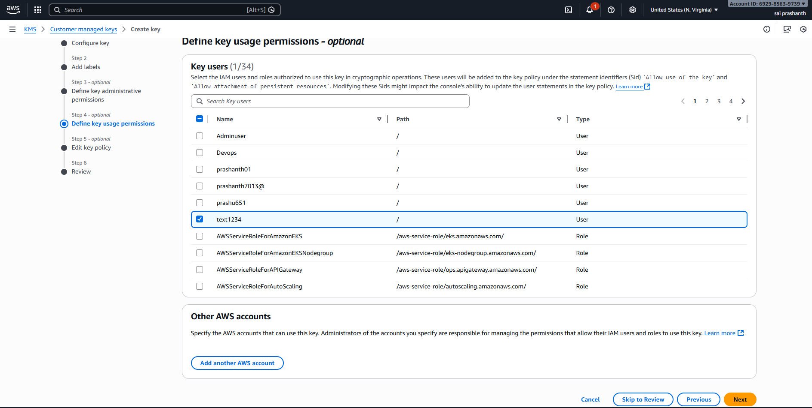
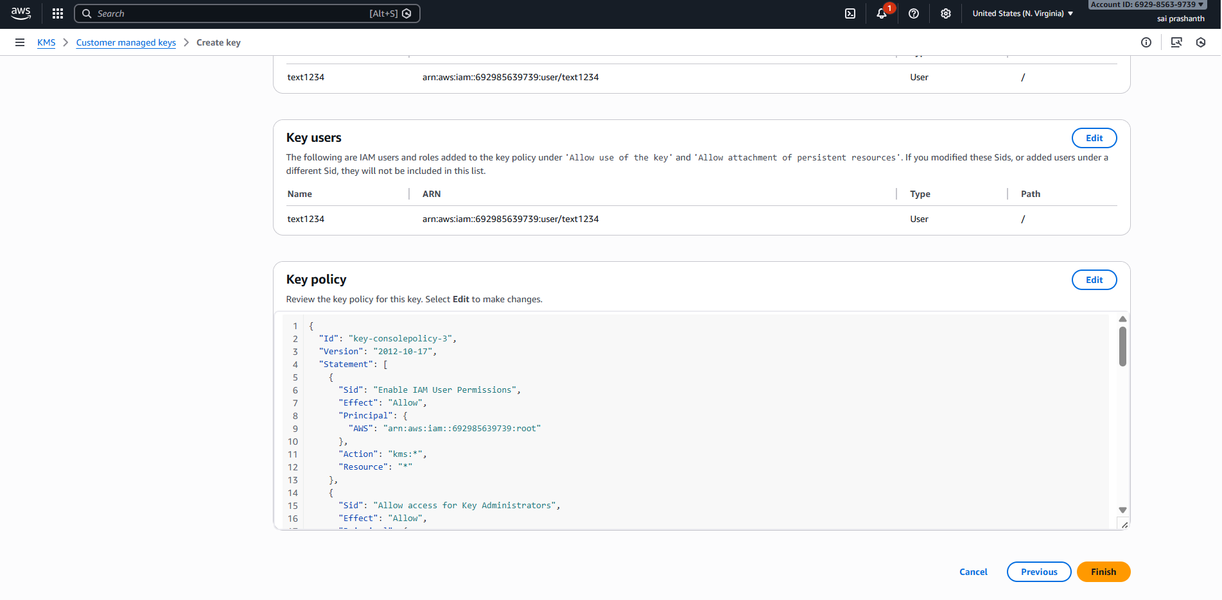
once you have clicked finish---you can see the key has been created by your own way
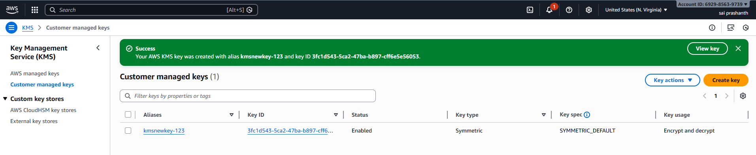
now I have attached another object in my S3 bucket
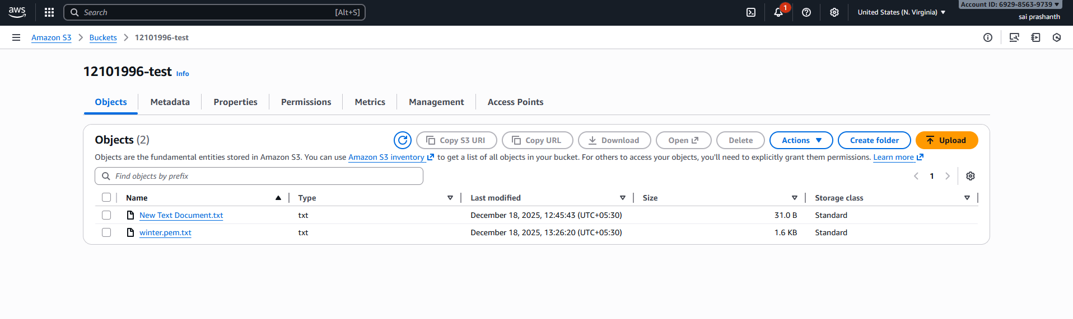
giving access with my key
go to properties—click on server side encryption settings

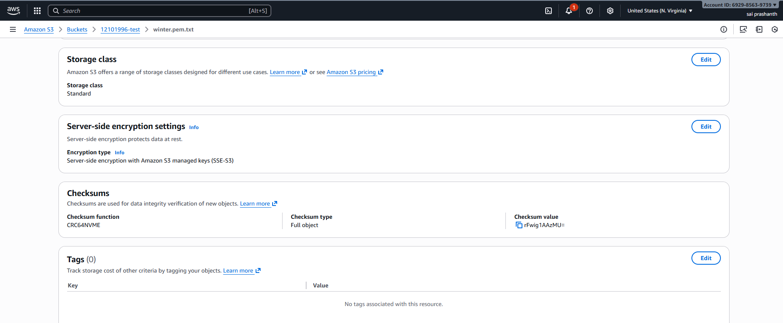
in encryption type select second option encryption with AWS KMS
choose from AWS KMS keys
select your created key—click on save changes
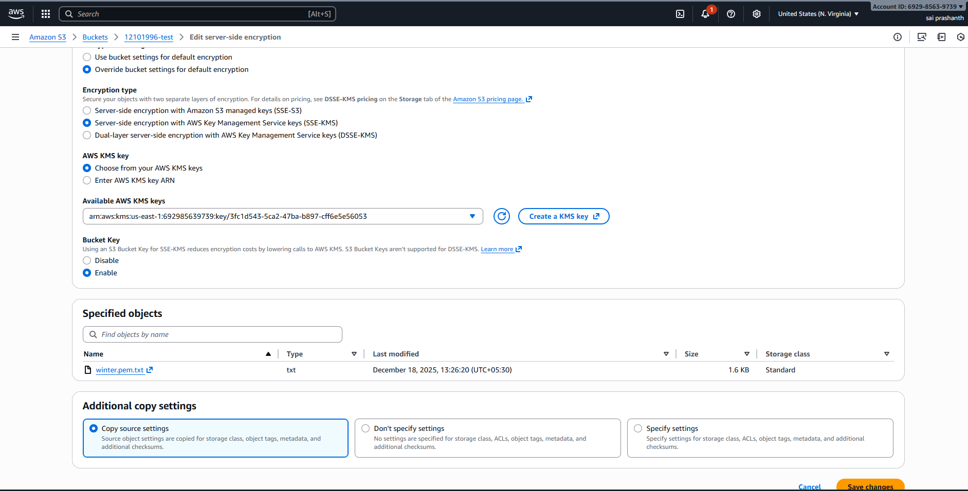
validation steps:
now I have logged as IAM user text1234
clicked on S3---selected my bucket---clicked on new object file which I have uploaded—you can see with my key it has been updated
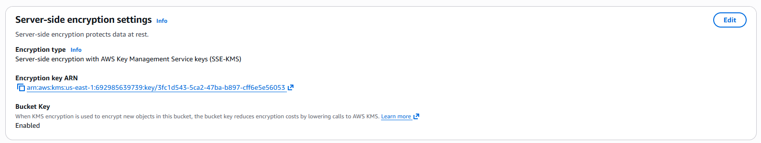

now clicked on open tab
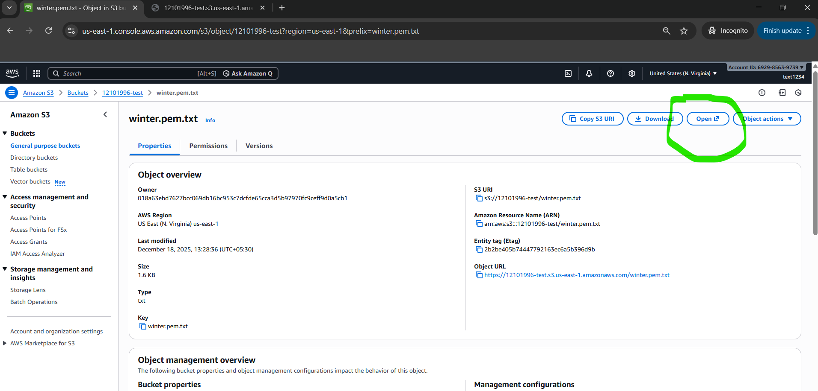
you can see the file content from the user as having permission for that particular user and with particular key
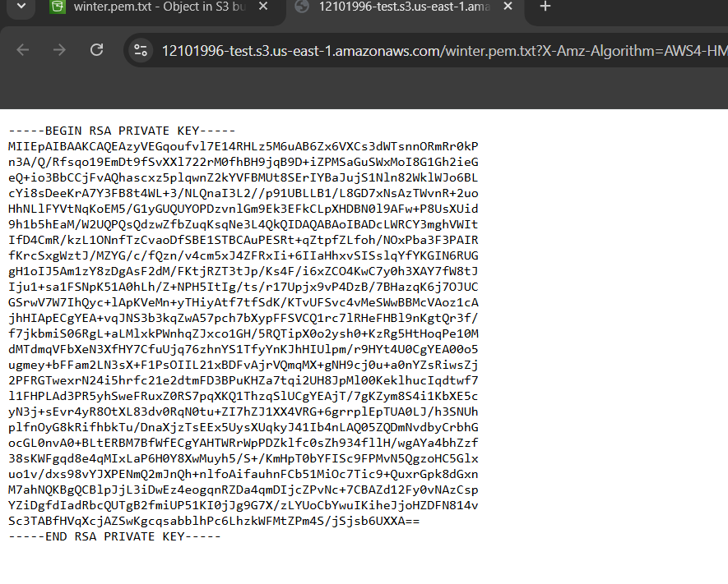
secret management
how to keep secret your credentials like your user’s name and password secretly through database
objective: to keep your credentials in secret by creating database
prerequisites:
rds database
username and password
secret manager
step by step process:
first, we need to create database—MariaDB
in credentials management—select managed in aws secret manager which is secure—and click on create database
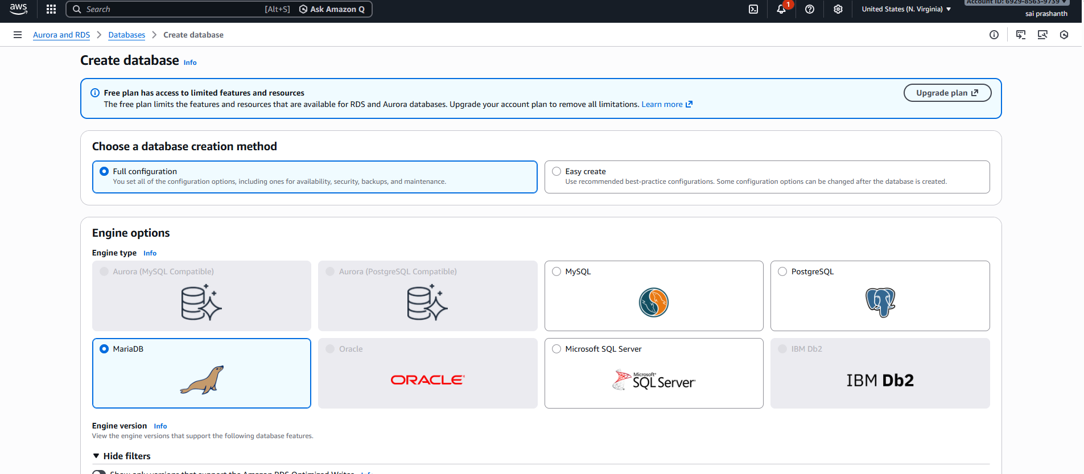
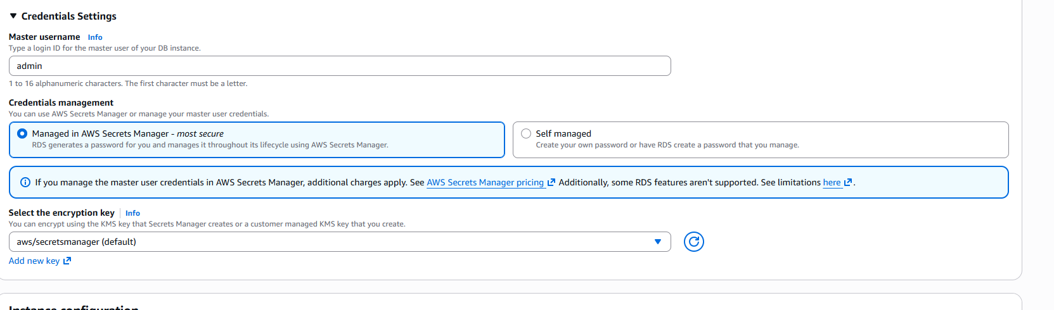
validation steps:
now you can check in secret manager—secrets
this database credentials has been secretly stored in secret management
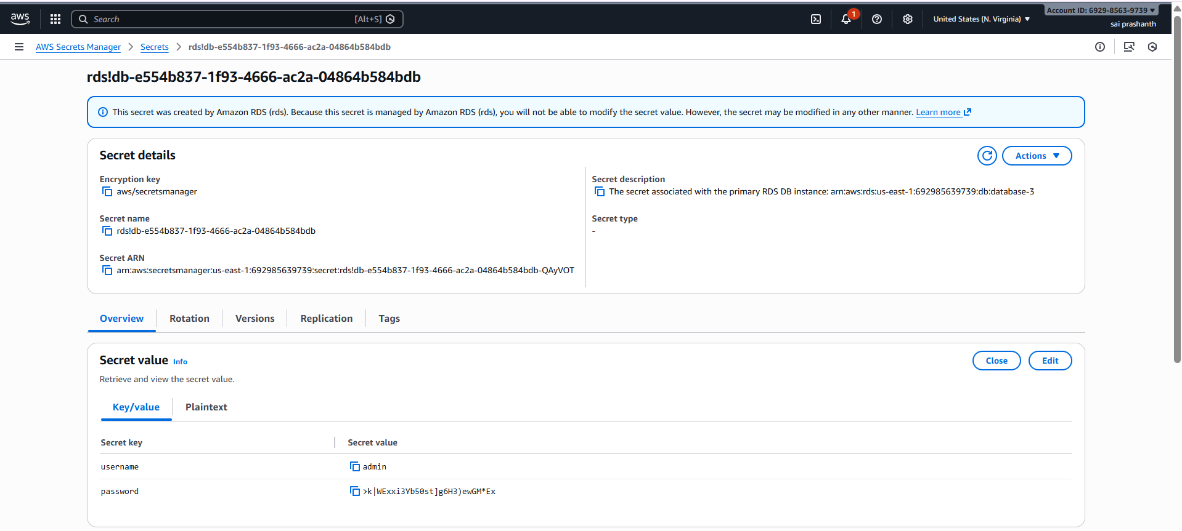
how to create a new secret in secret manager
objective: to create new secret with own credentials
prerequisites:
aws
secret manager
key value
encryption key
step by step process:
go to aws secret manager---click on store a new secret—choose secret type other type of secret—add the username and password in key value—click on next
here I gave username as admin and password as Sairam@123
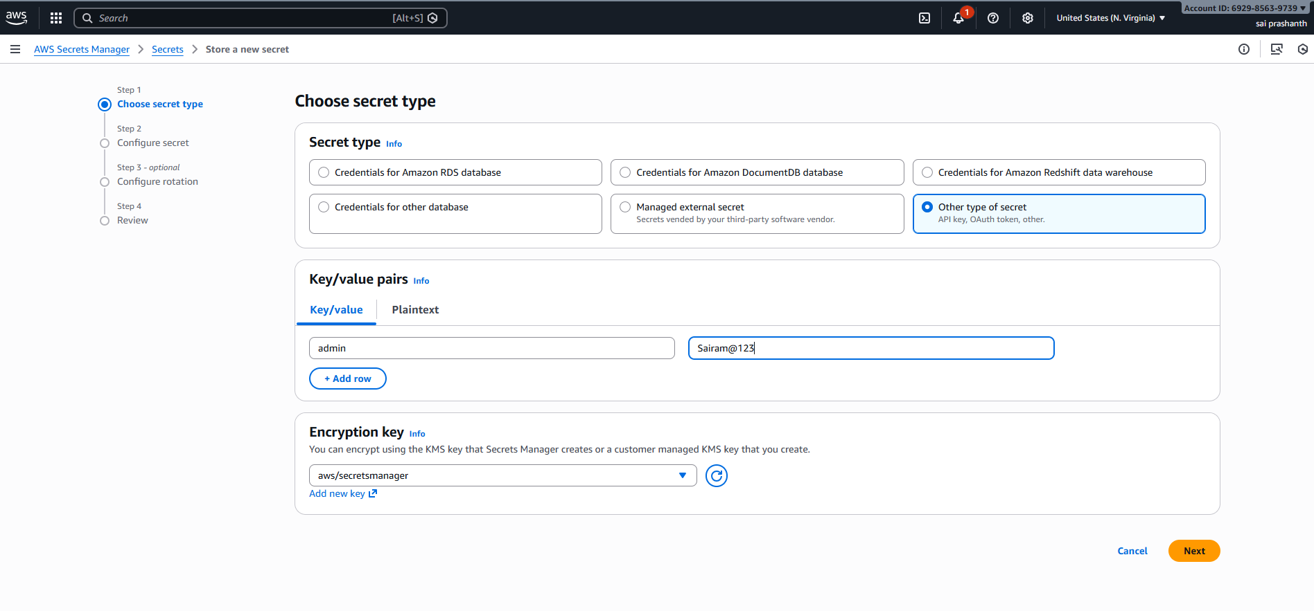

give one secret name ---description can be optional—click on next
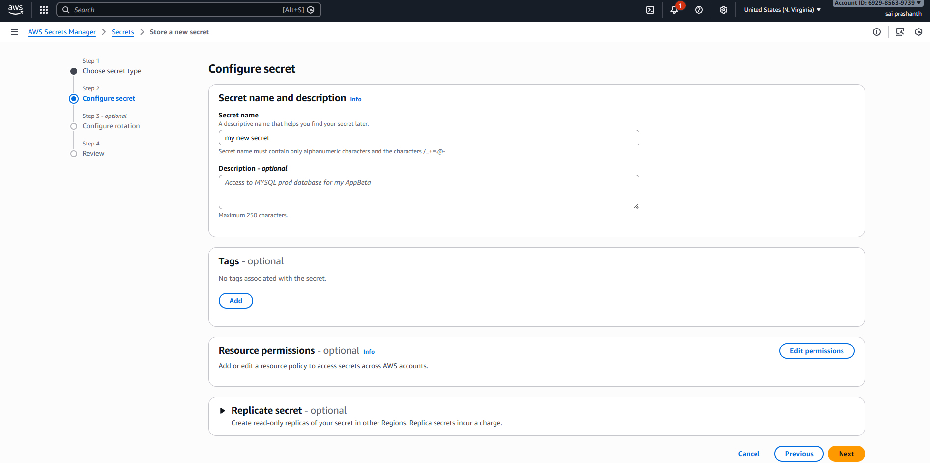
after clicking next---next—click on store
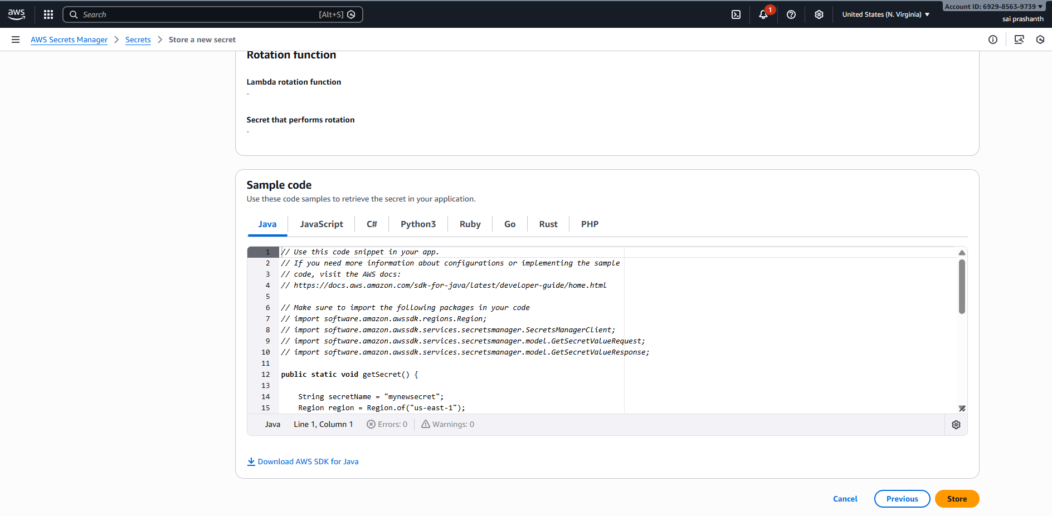
validation steps:
now you can see the secret has been stored---can see in secrets list
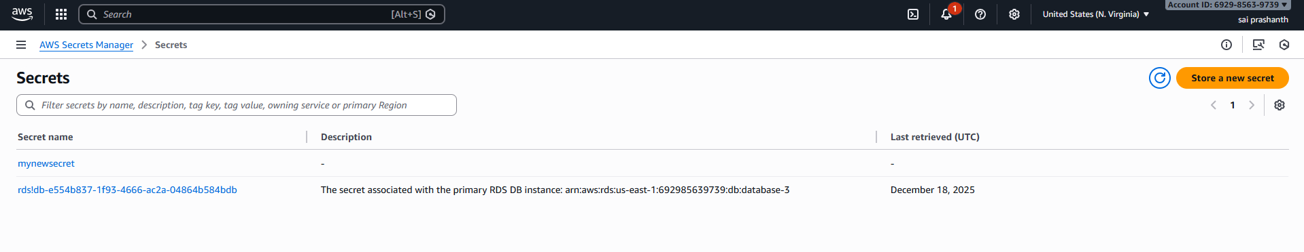
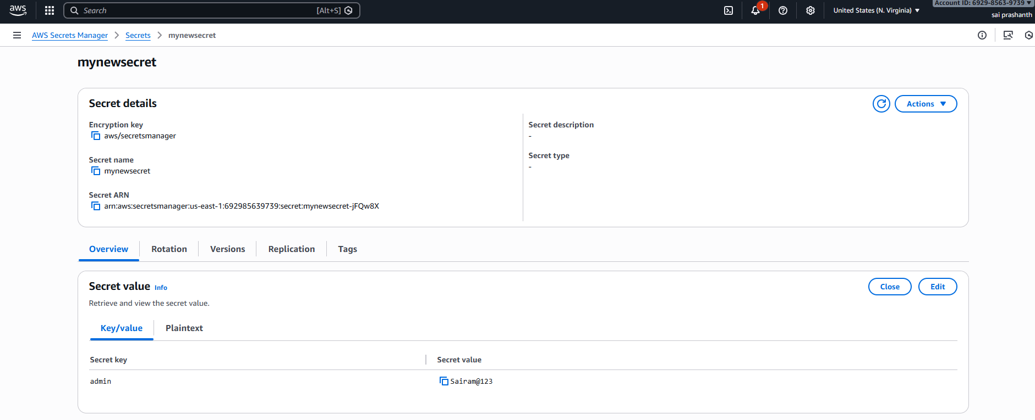
create a secret key by using CLI
objective: to create secret key by in CLI
prerequisites:
AWS
secret manager
CLI
step by step process:
first open your git bash—aws configure---enter access key and secret key, region and format
now enter the code as below to create the secret key
aws secretsmanager create-secret \
--name new-db-secret \
--description "Database credentials" \
--secret-string '{"username":"prashanth","password":"Srikanth2918280"}'
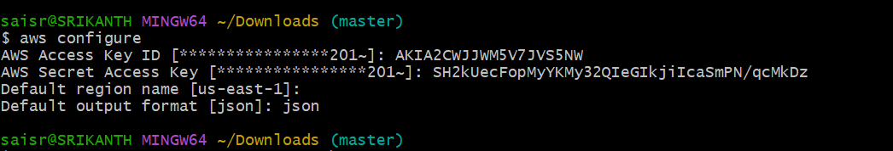
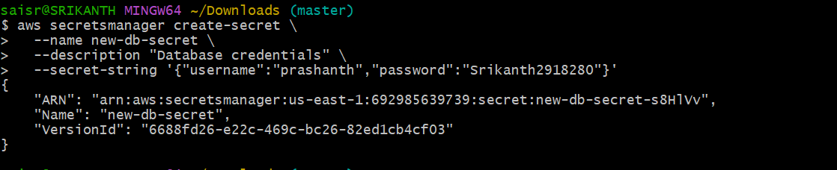

validation steps:
now you can verify secret in GUI
